CHAPTER 8: Forces, energy and motion
Worksheet 8.1

Speed and velocity
Student: Class:

Calculating average speed
1. The average speed (v) for a journey is calculated using the formula:
v = | d
 | t
where d = distance travelled and t = time taken.
Complete the following table. Make sure you include the appropriate units for each quantity.
Distance travelled | Time taken | Average speed
100 m | 20 s
3 km |  | 60 km/h
 | 15 s | 20 m/s
2 km |  | 25 m/s

Average speed and average velocity
2. Two vehicles (X and Y) travel from A to C along different paths as shown in the diagram (not drawn to scale). X travels along the path ABC and vehicle Y travels along AC. The triangle ABC is a right-angled triangle. A is north of B.
 |  | 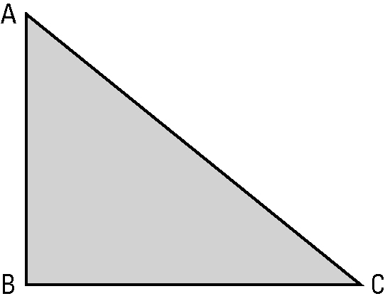 | 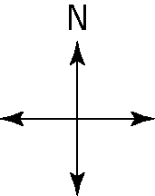
Both vehicles take 70 s for the trip.
Perform the necessary calculations to complete the following table.
Average speed of X | Average velocity of X | Average speed of Y | Average velocity of Y

